ASSIGNMENT 10

1. **select** * **from** cd.facilities

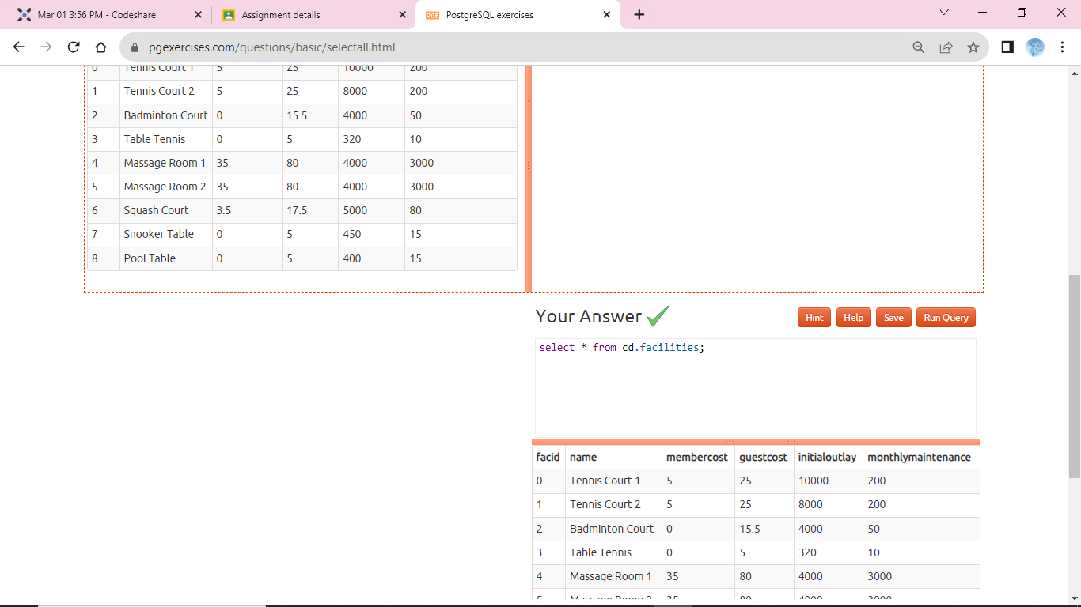

1. **select** name, membercost **from** cd.facilities

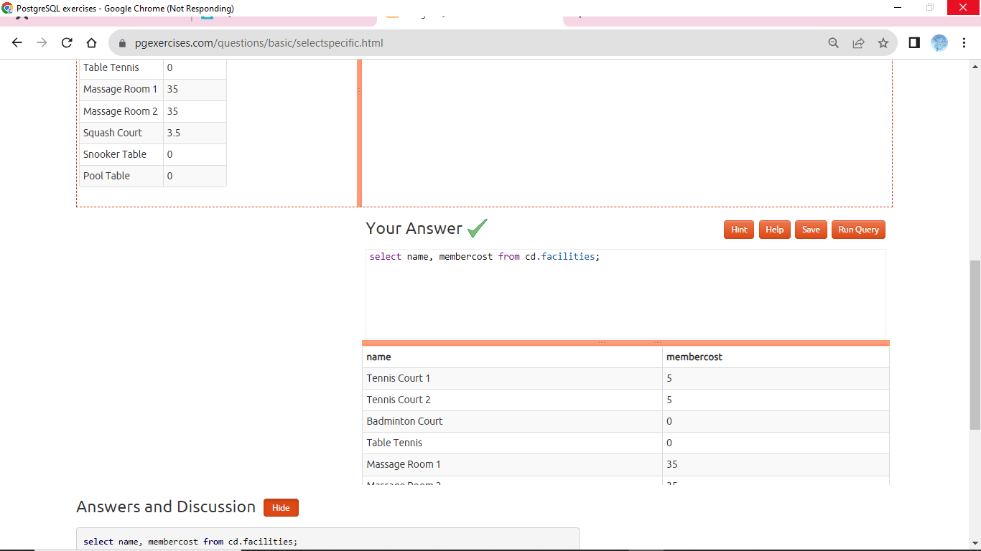

1. **select** * **from** cd.facilities **where** membercost > 0

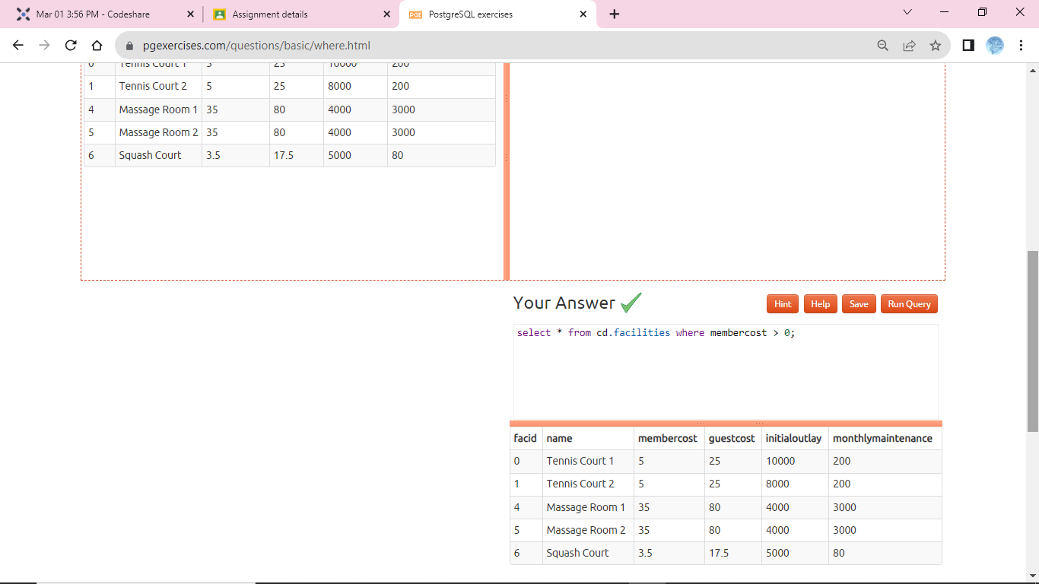

1. **select** facid, name, membercost, monthlymaintenance

**from** cd.facilities **where** membercost > 0 **and** (membercost < monthlymaintenance/50.0)

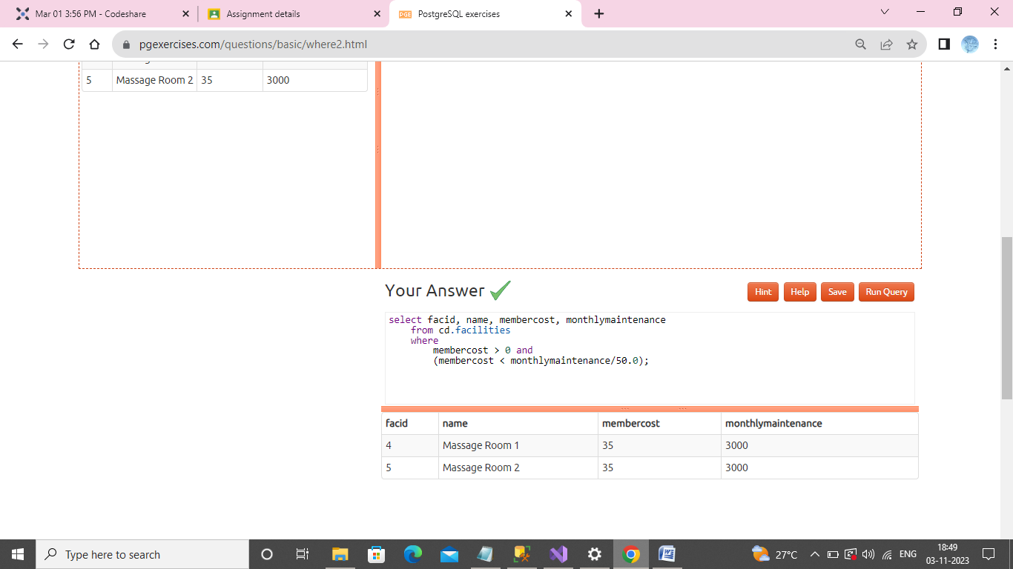

1. **select** * **from** cd.facilities **where** name **like** '%Tennis%'

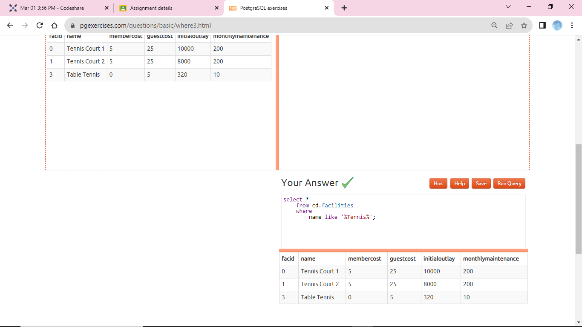

1. **select** * **from** cd.facilities **where** facid **in** (1,5)

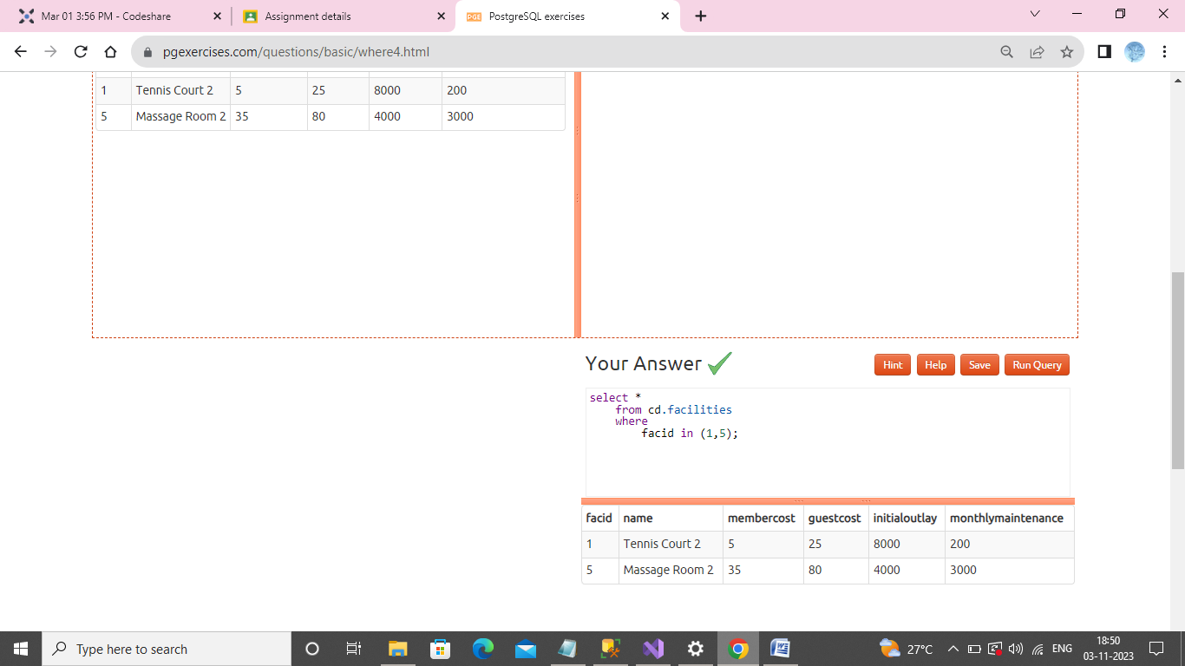

1. **select** name, **case** **when** (monthlymaintenance > 100) **then** 'expensive' **else** 'cheap' **end** **as** cost **from** cd.facilities

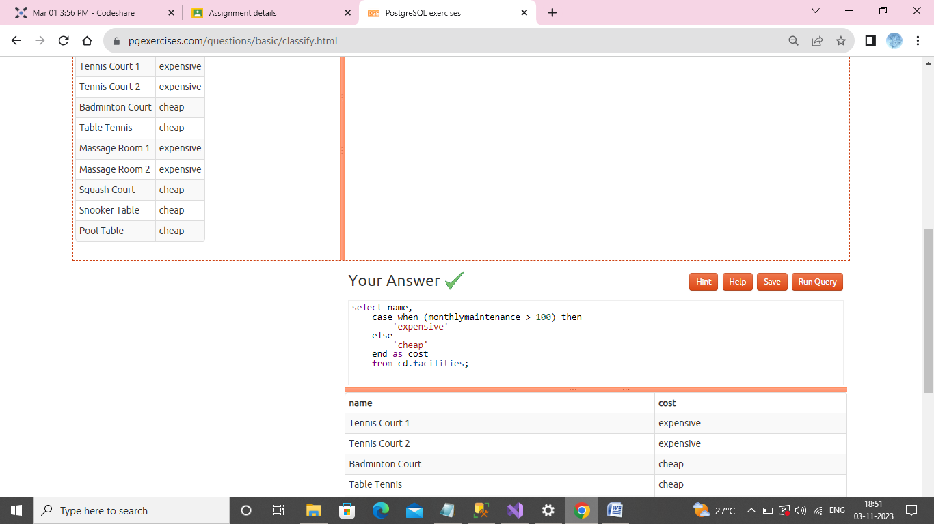

1. **select** memid, surname, firstname, joindate **from** cd.members

**where** joindate >= '2012-09-01'

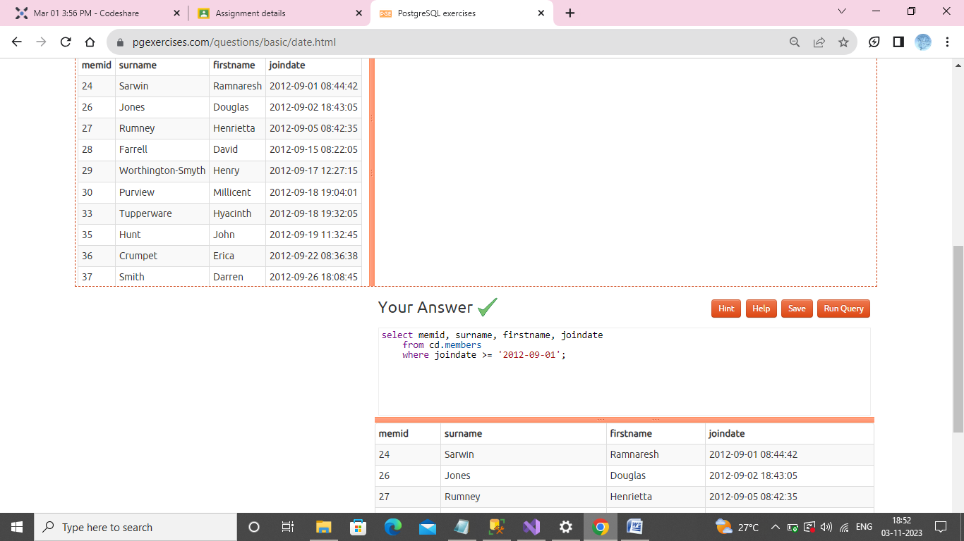

1. **select** **distinct** surname **from** cd.members **order** **by** surname limit 10

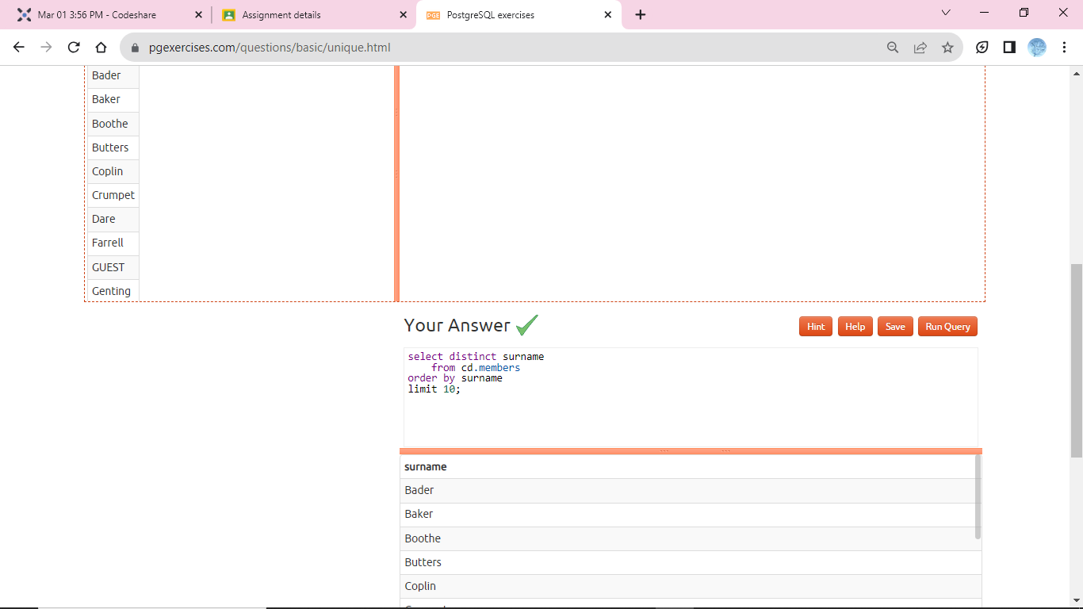

1. **select** surname **from** cd.members **union** **select** name **from** cd.facilities

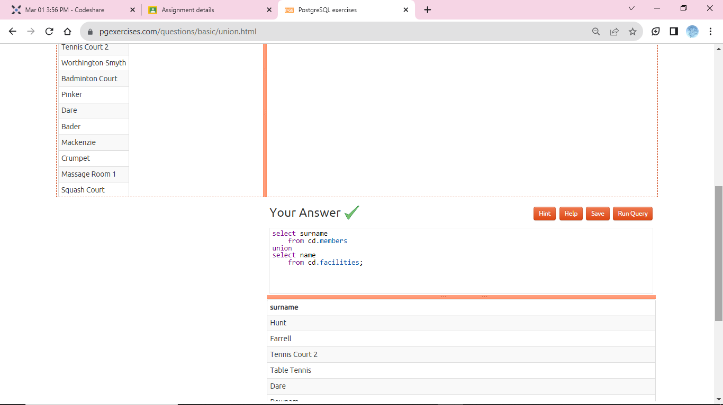

1. **select** max(joindate) **as** latest **from** cd.members

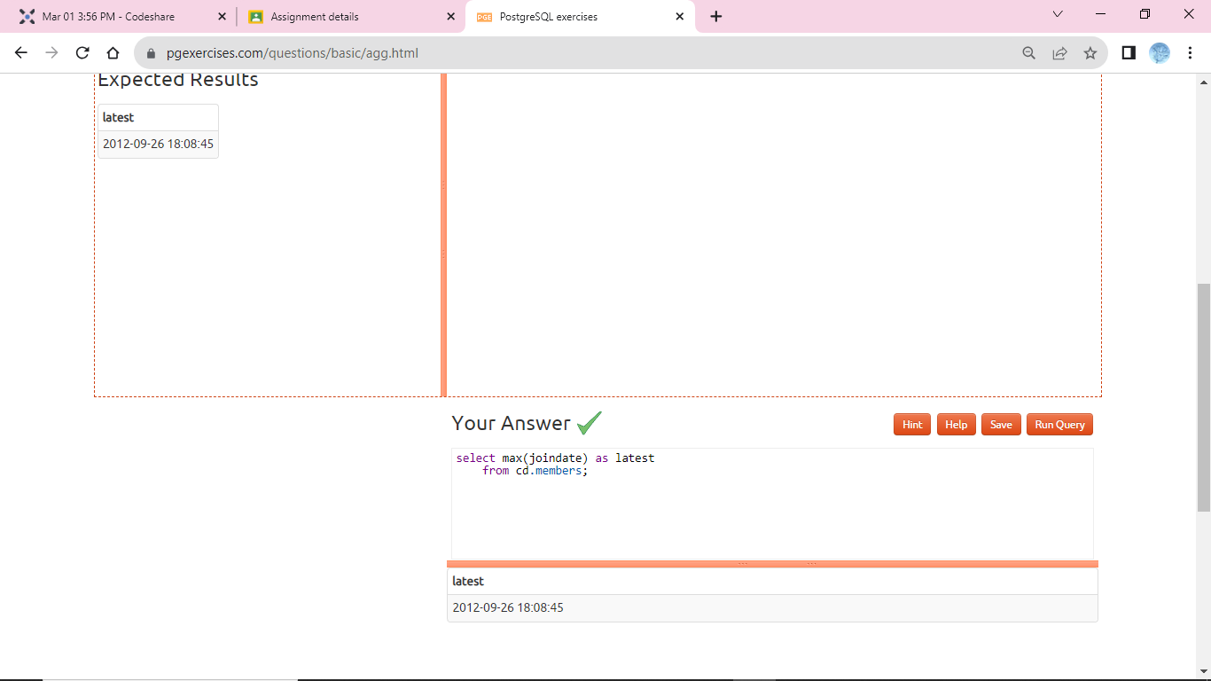

1. **select** firstname, surname, joindate **from** cd.members **where** joindate = (**select** max(joindate) **from** cd.members)

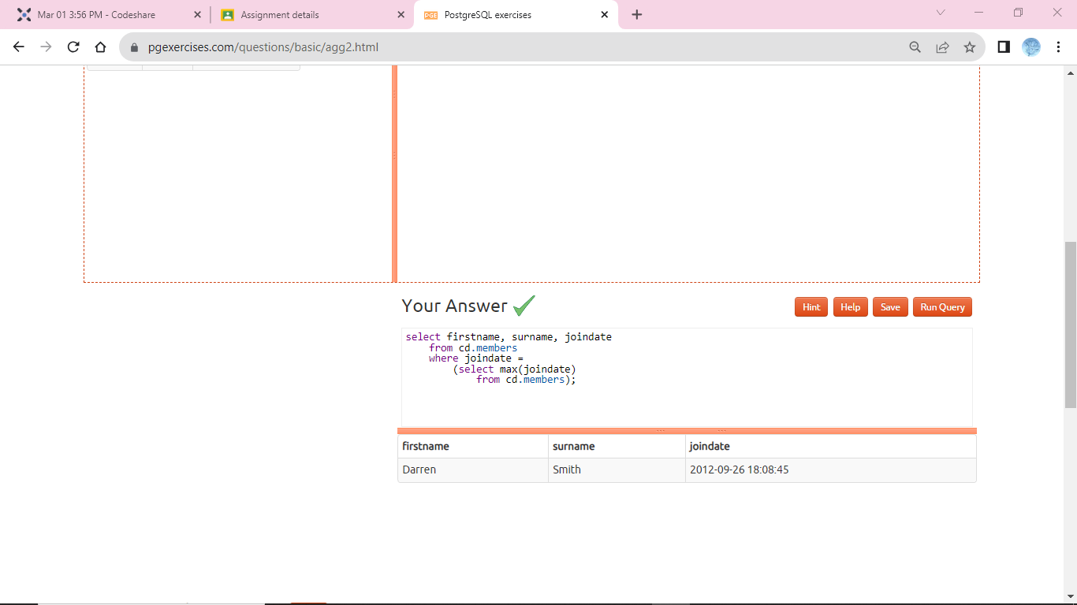

1. **select** bks.starttime **from** cd.bookings bks

**inner** **join** cd.members mems **on** mems.memid = bks.memid

**where** mems.firstname='David' **and** mems.surname='Farrell'

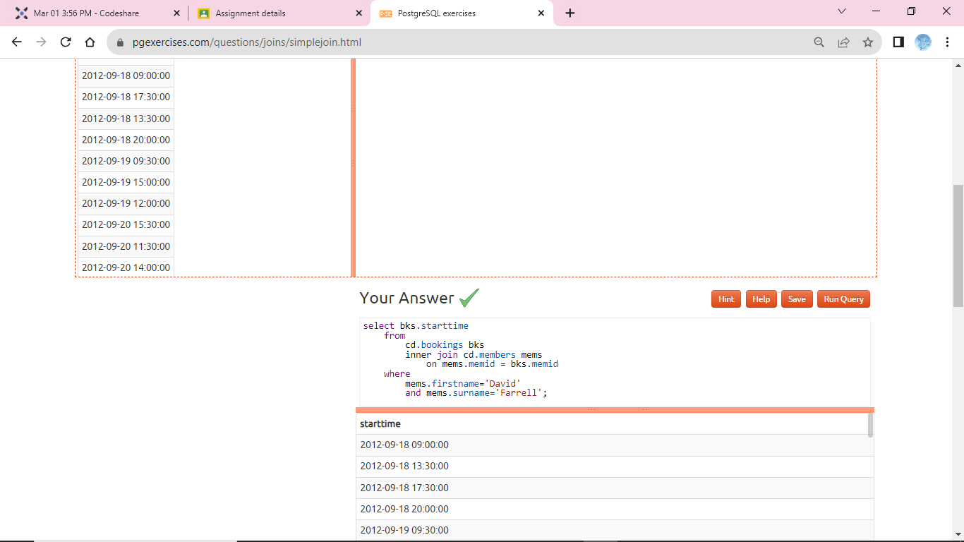

1. **select** bks.starttime **as** **start**, facs.name **as** name **from** cd.facilities facs

**inner** **join** cd.bookings bks **on** facs.facid = bks.facid

**where** facs.name **in** ('Tennis Court 2','Tennis Court 1') **and** bks.starttime >= '2012-09-21' **and** bks.starttime < '2012-09-22' **order** **by** bks.starttime

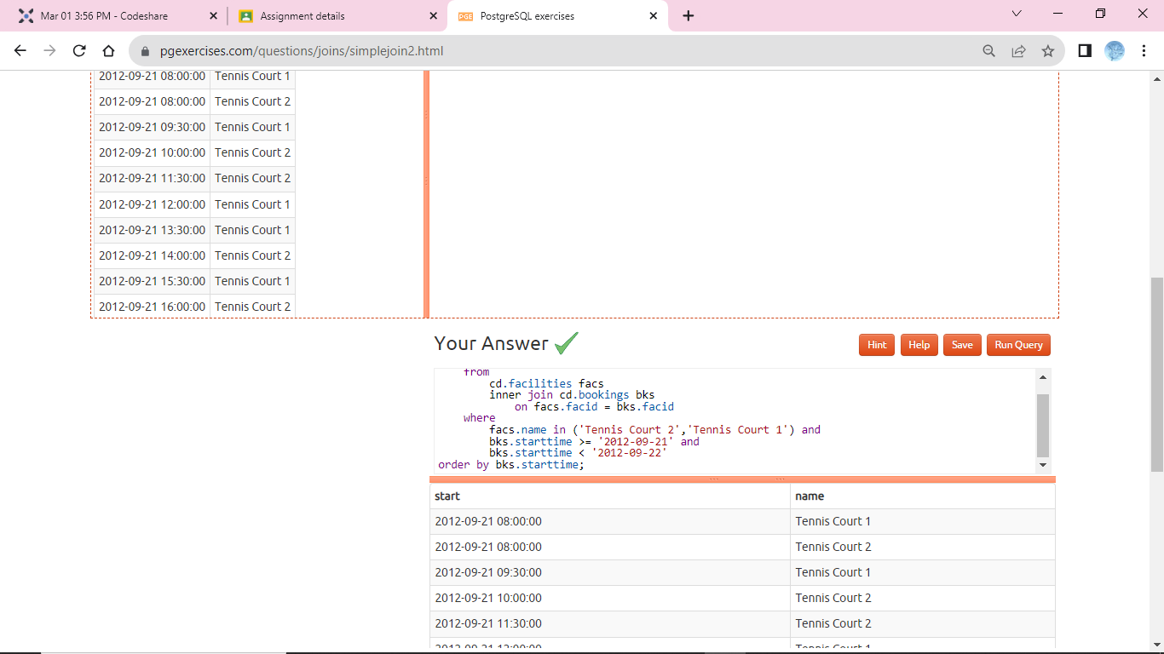

1. **select** **distinct** recs.firstname **as** firstname, recs.surname **as** surname

**from** cd.members mems

**inner** **join** cd.members recs **on** recs.memid = mems.recommendedby

**order** **by** surname, firstname

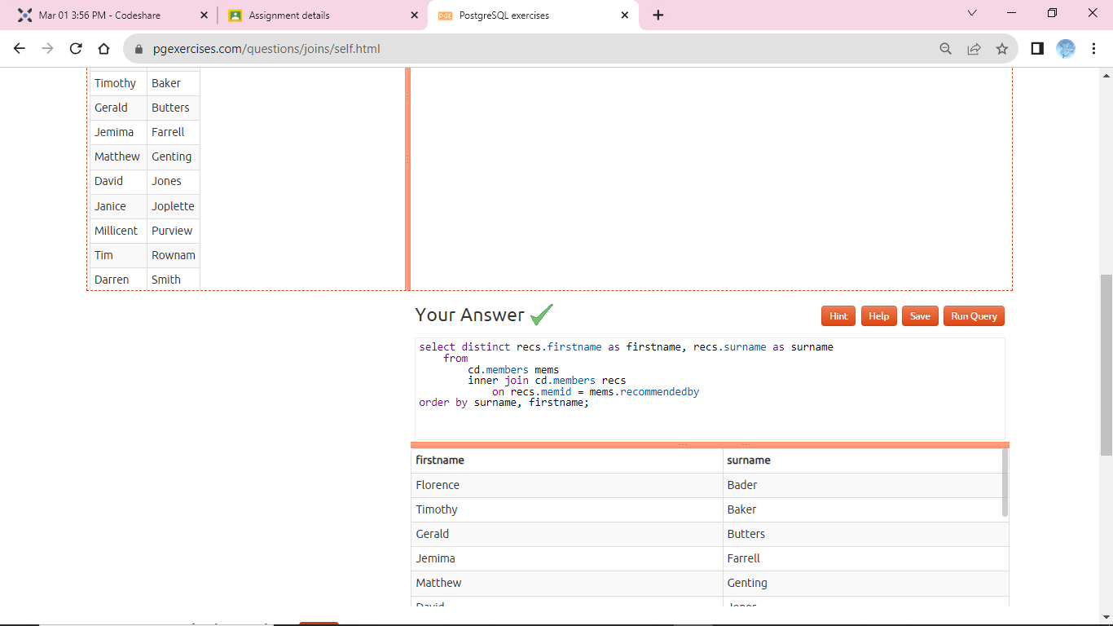

1. **select** mems.firstname **as** memfname, mems.surname **as** memsname, recs.firstname **as** recfname, recs.surname **as** recsname **from** cd.members mems

**left** **outer** **join** cd.members recs **on** recs.memid = mems.recommendedby

**order** **by** memsname, memfname

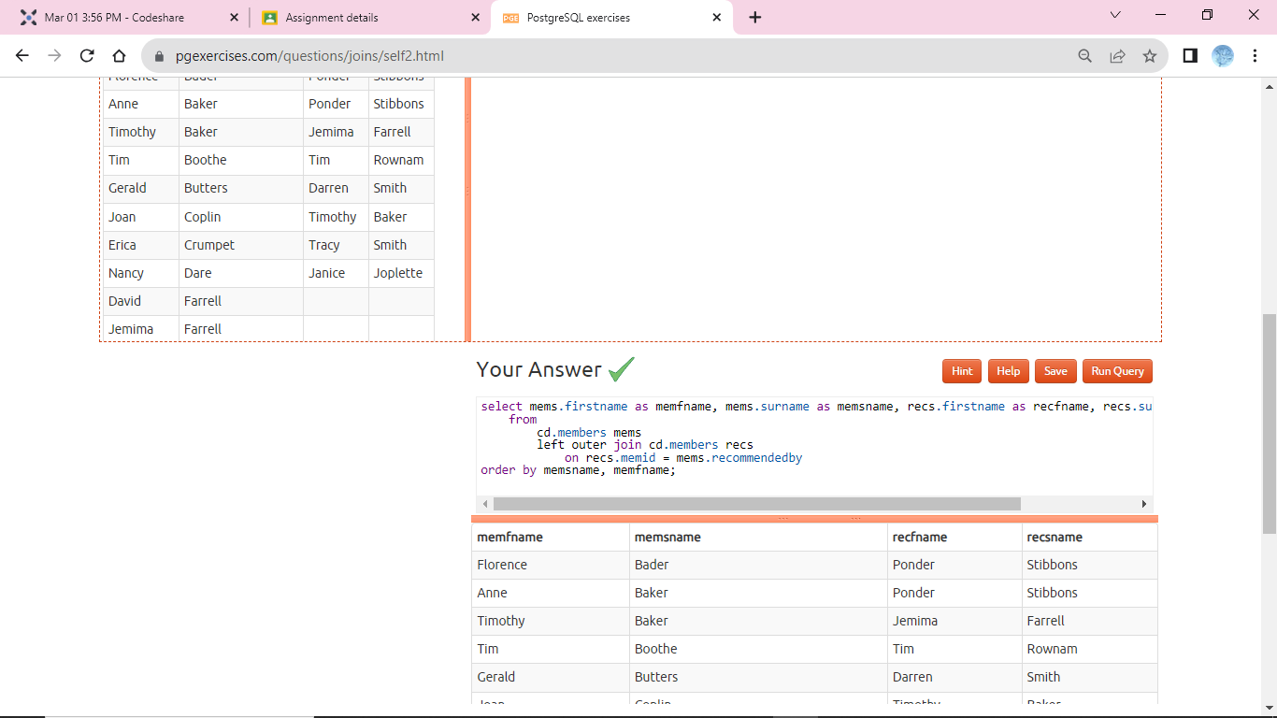

1. **select** **distinct** mems.firstname || ' ' || mems.surname **as** member, facs.name **as** facility **from** cd.members mems

**inner** **join** cd.bookings bks **on** mems.memid = bks.memid

**inner** **join** cd.facilities facs **on** bks.facid = facs.facid **where** facs.name **in** ('Tennis Court 2','Tennis Court 1')

**order** **by** member, facility

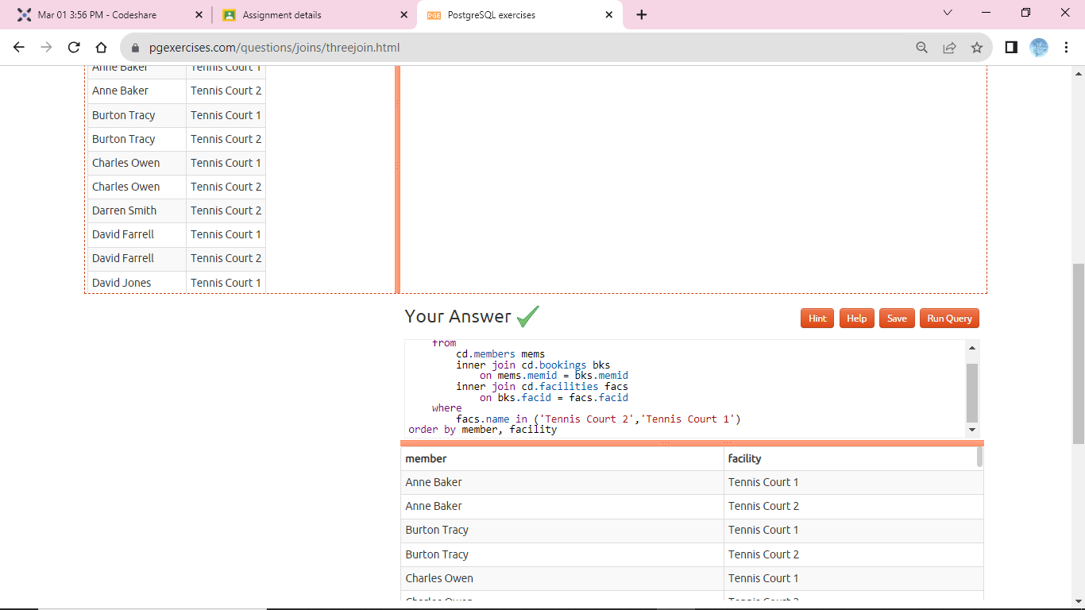

1. **select** mems.firstname || ' ' || mems.surname **as** member, facs.name **as** facility, **case** **when** mems.memid = 0

**then** bks.slots*facs.guestcost **else** bks.slots*facs.membercost **end** **as** cost

**from** cd.members mems **inner** **join** cd.bookings bks **on** mems.memid = bks.memid

**inner** **join** cd.facilities facs **on** bks.facid = facs.facid

**where** bks.starttime >= '2012-09-14' **and** bks.starttime < '2012-09-15' **and** ( (mems.memid = 0 **and** bks.slots*facs.guestcost > 30) **or** (mems.memid != 0 **and** bks.slots*facs.membercost > 30) )

**order** **by** cost **desc**

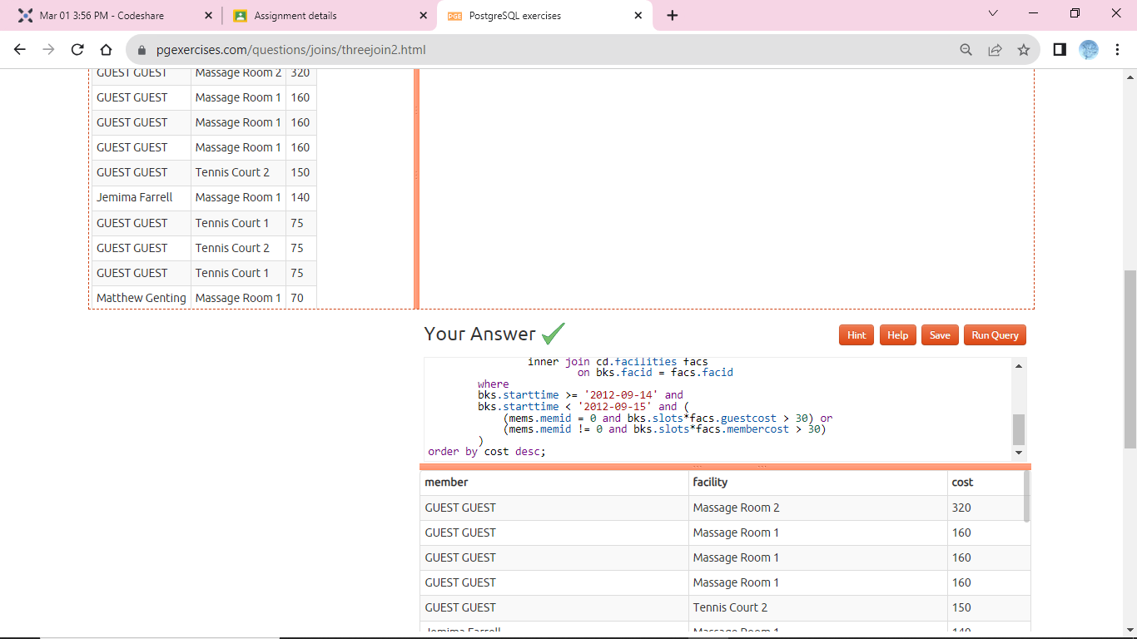

1. **select** **distinct** mems.firstname || ' ' || mems.surname **as** member, (**select** recs.firstname || ' ' || recs.surname **as** recommender **from** cd.members recs

**where** recs.memid = mems.recommendedby )

**from** cd.members mems **order** **by** member

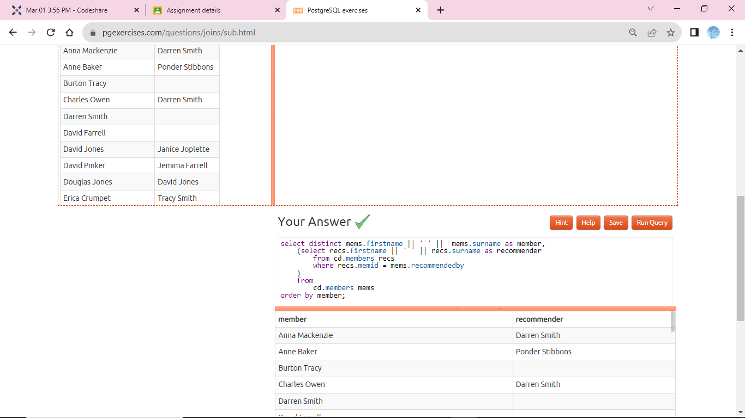

1. **select** member, facility, cost **from** ( **select** mems.firstname || ' ' || mems.surname **as** member, facs.name **as** facility,

**case** **when** mems.memid = 0 **then** bks.slots*facs.guestcost **else** bks.slots*facs.membercost **end** **as** cost **from** cd.members mems

**inner** **join** cd.bookings bks **on** mems.memid = bks.memid

**inner** **join** cd.facilities facs **on** bks.facid = facs.facid **where** bks.starttime >= '2012-09-14' **and** bks.starttime < '2012-09-15' ) **as** bookings **where** cost > 30

**order** **by** cost **desc**

